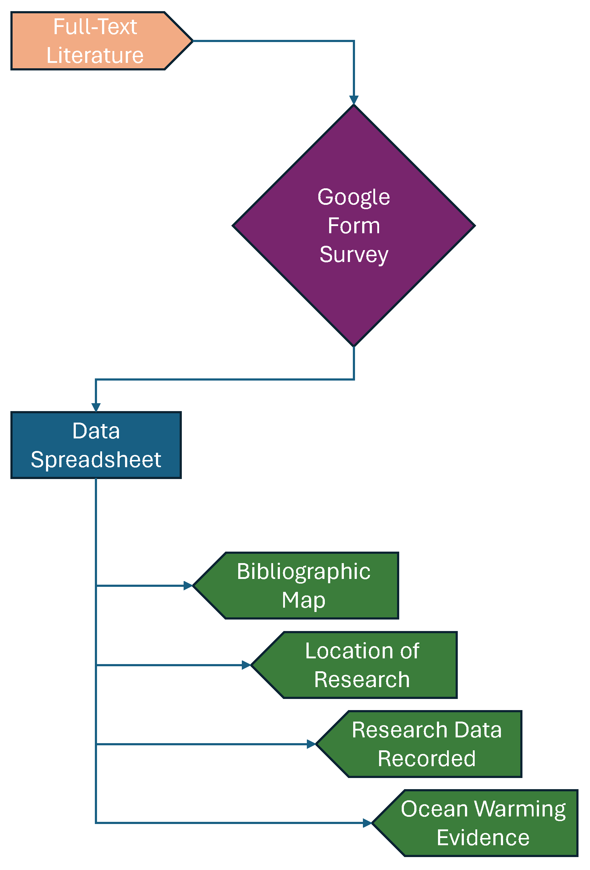

Figure 3 The data mapping methods flow chart for this systematic map.